LINUX COMMANDS:

1. 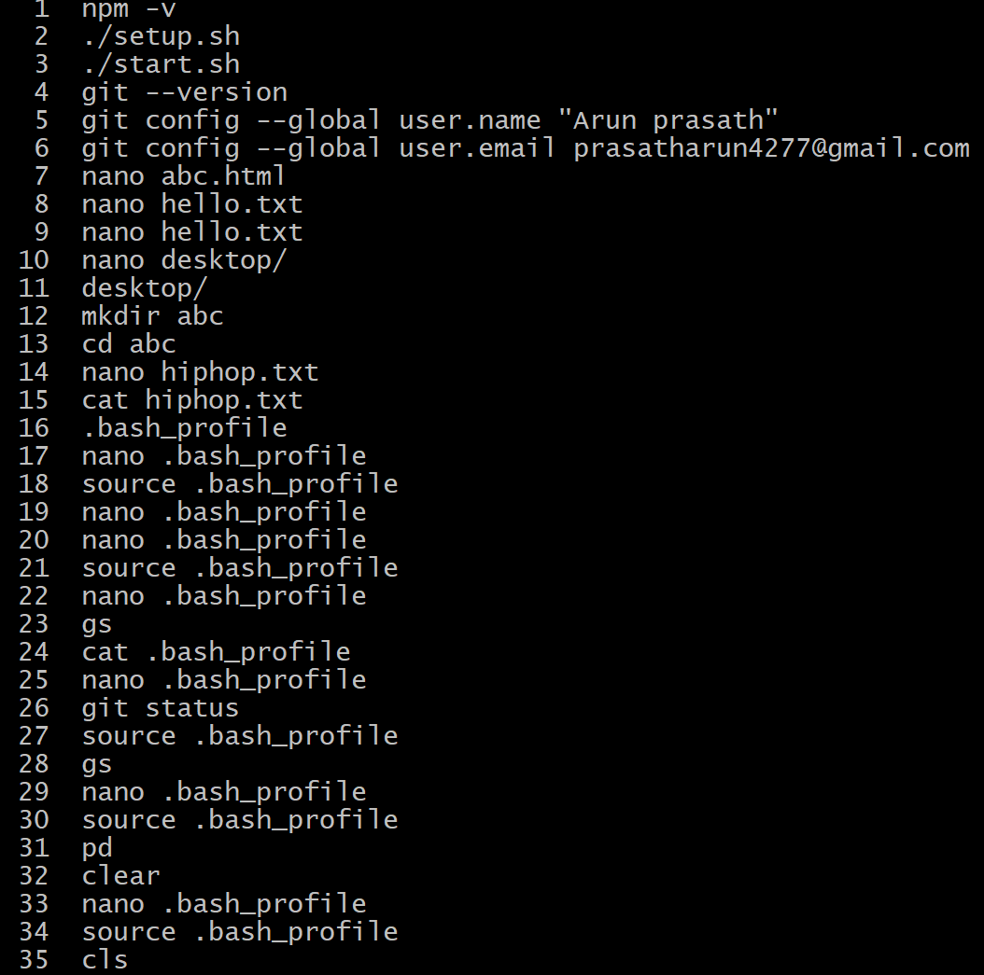ALL THE BASIC COMMANDS:
2. Commands that is used to perform with files and updating of it :